HILLY FIELDS FOOTBALL CLUB
SEASON 24: 1990-91
FIRST TEAM:
SOUTH LONDON FOOTBALL FEDERATION:
P W D L F A Pts Pos
Division 12 1 0 11 20 54 2
Beckenham Hospital Cup 1 0 0 1 2 7
Burwood Cup 4 1 2 1 11 12
London Junior Cup 1 0 0 1 1 11
Tom Betton Invitation 4 3 0 1 9 7 FINAL
Friendly 4 3 0 1 33 14
TOTAL 26 8 2 16 76 105
Apps Gls Apps Gls
Charlie Benson 4 0 Mark Jowitt 8 0
David Brown 11 2 Alex Leach 1 0
Terry Brown 19 0 Steve Morton 4 0
Mark Cantwell 12 1 Jake Murray 1 0
Dean Chatfield 5 5 Jamie Murray 15 11
Mark Cooper 1 0 Joe Nixon 2 0
Rick Ellis 11 3 Stuart Parsley 7 0
Jim Flood 23 0 Paul Quinn 4 1
Sean Foley 1 0 Steve Quinn 2 0
Steve Ford 24 9 Mark Rumbelow 25 1
Keith Foster 2 0 Nick Rumbelow 10 1
Len Franklin 4 0 Tom Salacuri 24 26
Nick Gayle 7 0 Peter Saunders 2 0
James Greet 5 1 Charlie Shoppee 23 0
Robert Hare 18 9 John Wood 14 2
Jeff Harrod 14 1 Colin 1 0
Malcolm Hill 1 0 Paul 1 0
Mike Jefferys 1 0
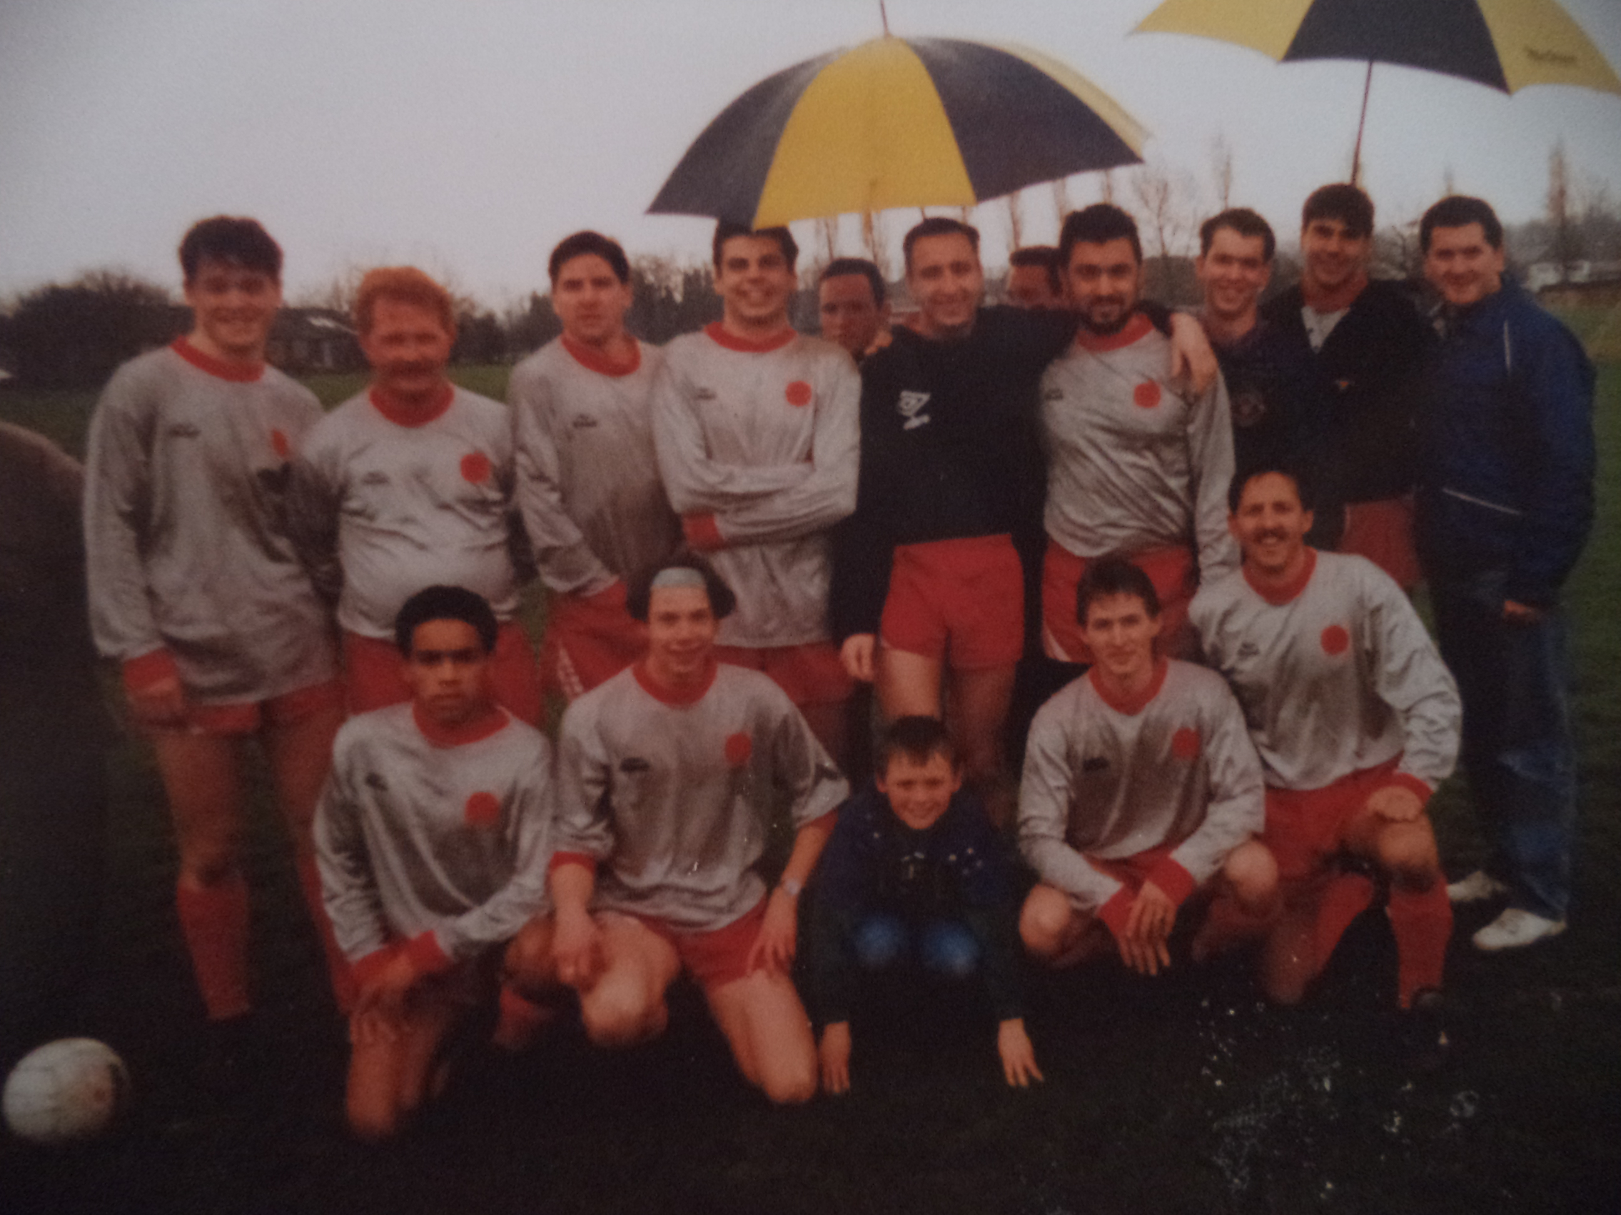
L-R Back: Jamie Murray, Jim Flood, Rob Hare, Mark Rumbelow, Jake Murray, John Wood, Tommy Salacuri, Stuart Parsley, Nick Rumbelow, Len Franklin
L-R Front: Nick Gayle, Jeff Harrod, Ben Ford, Steve Ford, Charlie Shoppee

